Southeast Regional Climate Center

Research Paper Series

Determining the Optimal Number of Stations for the
United States Climate Reference Network
Final Report

Michael J. Janis

Southeast Regional Climate Center
South Carolina Department of Natural Resources
Columbia, SC 29205
email: janis@dnr.state.sc.us
telephone: 803-734-9569
fax: 803-734-9573

Kenneth G. Hubbard

High Plains Regional Climate Center
University of Nebraska
830728 Chase Hall
Lincoln, NE 68583-0728

Kelly T. Redmond

Western Regional Climate Center
Desert Research Institute
2215 Raggio Parkway
Reno, NV 89512

April 2002

Abstract

The National Oceanic and Atmospheric Administration's National Climatic Data Center, to improve the capacity to observe climatic change and variability, is establishing the U.S. Climate Reference Network (CRN). A goal of this network is to provide long-term homogeneous observations of temperature and precipitation that can be coupled with historical observations for detection and attribution of climatic change. The purpose of this study is to estimate the number and distribution of CRN observing stations required to reproduce, within predetermined monitoring goals, the annual temperature and precipitation variability across the contiguous United States. It was hypothesized that a greater station density would be required to achieve the monitoring goal in those areas with highest climate variability. The analysis was conducted on a grid cell basis to allow for this possibility. Based on an existing high-resolution network of weather stations, stratified sampling techniques are used to select stations within 2.5° latitude × 3.5° longitude grid cells. Monte Carlo resampling techniques are applied to stations within each grid cell to successively lower the resolution compared to the reference or baseline network. Measures of similarity between lower resolution networks and baseline networks are generated for each grid cell. Thus, grid cell densities required to meet pre-determined network monitoring goals can be determined in a manner that reflects the climate variability from region to region. It was found that a network of 327 stations is required to meet a combined temperature-trend monitoring goal of 0.10°C per decade and a precipitation-trend monitoring goal of 2.0% of median precipitation per decade.

Introduction

The initiation and ongoing deployment of a Climate Reference Network (CRN) has been undertaken to monitor present and future climatic variability across the United States. The initial proposal for the CRN assumed a network of about 250 stations would be sufficient to capture the climatic signal for the nation. This station density was inferred from a methodological examination of Twentieth Century US precipitation trends (Karl and Knight 1998). Their study estimated that a network of 182 stations could reasonably reproduce the 1910-1996 trend in annual precipitation computed from the climate division data set. The purpose of this study is to refine the estimate of the spatial density and total number of US stations required and to relate the station density to predetermined monitoring goals.

This study objectively estimates the number of stations that reproduce, within predetermined monitoring goals, the annual temperature and precipitation variability across the United States. Previous studies have examined the role of station density in capturing the spatial variability in the regional data sets. For example, Hubbard (1994) found that one station every 60 km in relatively simple terrain was adequate to capture 90% of the spatial variability in daily temperature. Network resolution for capturing daily precipitation variability was an order of magnitude higher (5 km). Based on an 814-station subset of the US Historical Climatology Network (HCN), DeGaetano (2000) found 321 station clusters represented the spatial variability of seasonal precipitation across the contiguous US. Since 101 of 321 total clusters were single-station clusters and the reference network was spatially coarse in the Western United States, at least 321 stations are necessary to resolve the spatial variability of seasonal precipitation across the contiguous United States. A 250-station network of for the contiguous US, assuming a uniform distribution, is equivalent to approximately one station every 180 km. Comparatively, with 1219 stations for the contiguous US, the HCN has approximately one station every 82 km (Easterling et al. 1996).

Air Temperature and Precipitation Data for the United States

Station data from networks with spacing averaging 40-80 km are used to provide initial discrete representations of climatic variability. Temperature and precipitation data are drawn from the 1971-2000 Climatography of the United States sequential database (CLIM81; NCDC 2002). CLIM81 contains 5313 stations with serially complete monthly average temperature and 7507 stations with serially complete monthly total precipitation over the period 1971-2000. CLIM81metadata are screened for flags associated with estimated or adjusted data. Stations containing more than three years with more than three flags each are culled from the analyses. The resulting networks consist of 3642 temperature stations (Fig.1) and 5156 precipitation stations (Fig.2). Sequential temperature and precipitation data are transformed based on the 1971-2000 reference period, into annual temperature anomalies and percent-of-median annual total precipitation.

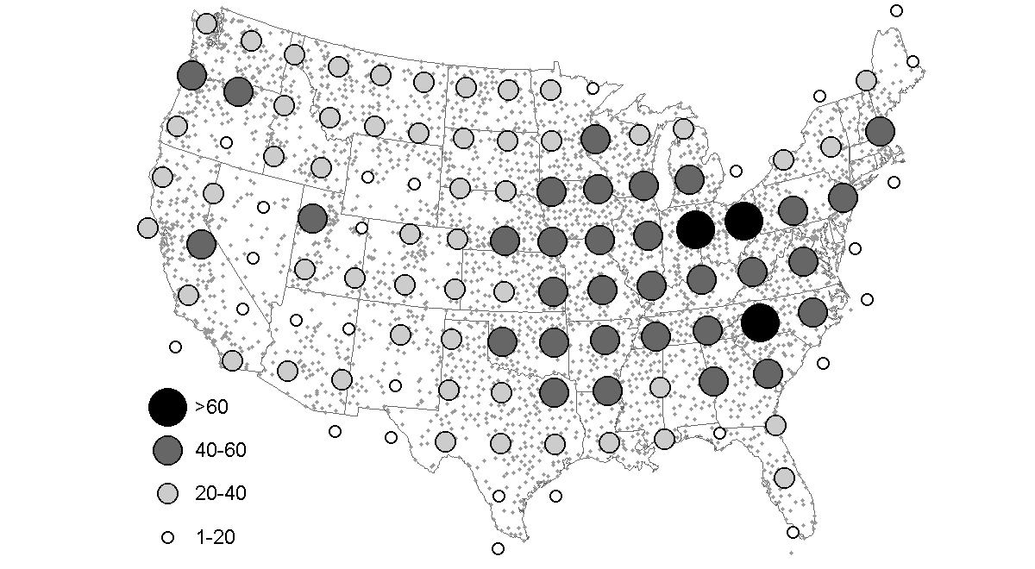
Figure 1 Distribution of 3642-station subset of CLIM81 with serially complete annual average temperature from 1971-2000. Graduated circles represent the number of stations within each grid cell.
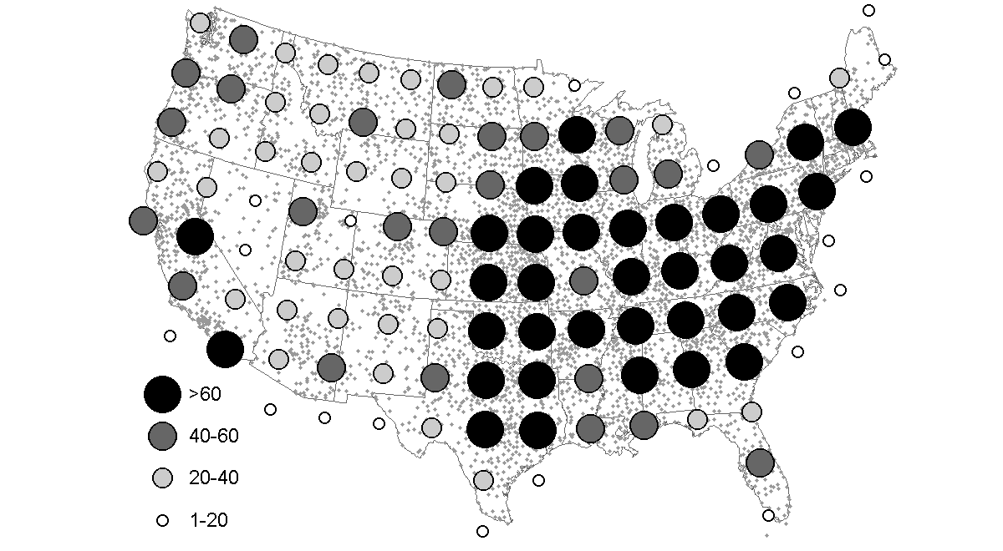
Figure 2 Distribution of 5156-station subset of CLIM81 with serially complete annual total precipitation from 1971-2000. Graduated circles represent the number of stations within each grid cell.

Methodology

The approach taken here is to systematically decrease network resolutions from a baseline network (e.g., CLIM81). This is accomplished by selectively removing the historical data for a number of stations from the network configuration. Each step involves generating measures of similarity between these networks of lower spatial resolution and the baseline network. An ideal density for climate monitoring networks is the number of stations that reproduce a behavior of interest in the baseline networks within predetermined climate monitoring goals. For example, a monitoring system for climatic change may have the following goals, “temperature change for any location within an area can be represented by a single station with an average mean-absolute-error less than 0.1°C per decade.” Although this work is centered on a definition of climatic behavior that consists of trends, this technique can be employed on other measures of climatic behavior.

Instead of performing a global spatial sampling of stations in CLIM81, these analyses are carried out on weather stations stratified into 2.5° latitude × 3.5° longitude grid cells. Of the 115 such grid cells covering the contiguous United States, only 6% of the grid cells contain fewer than 10 stations (Figs. 1 and 2). Local within-grid-cell sampling strategies overcome awkward network arrangements that can result from a randomly sampling across the entire network. A 2.5° × 3.5° grid-cell resolution was recommended for spatial analysis of United States Historical Climatology Network temperature and precipitation data (Easterling et al. 1996). This resolution also corresponds to the horizontal resolution of general circulation models (e.g., Hadley Coupled Model; Gordon et al. 2000). Globally, temperature and precipitation have been estimated over lower resolution 5.0° × 5.0° grid spacing (IPCC 2001, Easterling et al. 1997, Karl et al. 1994). Though climatological time series have been constructed over much higher spatial resolution (e.g., 0.5° × 0.5°; New et al. 2000), these resolutions produce approximately 3226 grid cells across the contiguous United States. Based on CLIM81 subsets these resolutions constitute an average of 1.4 stations per grid cell; inconsistent with the methods employed here. Additionally, higher resolution gridded estimates (e.g., 1.0° × 1.0°) are typically aggregated to analyze trends over larger spatial areas (e.g., Karl and Knight 1998).

Ensemble average time series of temperature anomalies and precipitation percentiles from either baseline or “lower resolution” networks are computed within each grid cell. The required number of stations to satisfy a monitoring goal defines the necessary grid-cell station density. After repeating the process for all grid cells, the total number of stations needed to satisfy the monitoring goal can be easily determined. In this case, the density is variable from region to region although the goal is the same from region to region. Local spatial analyses help determine where higher or lower network densities are needed to satisfy climate monitoring goals.

Within each grid cell, networks of lower spatial resolution (LSR) are derived by randomly selecting subsets of stations. The number of stations within each subset is incremented by one (1) so that all subset sizes from one to N-1 are examined (N is the total number of stations within a grid cell). Average or ‘ensemble’ time series based on individual station time series are generated for each LSR network. A Monte Carlo resampling procedure is applied to produce 100 different realizations of each LSR network size. This procedure addresses the effect of multiple network configurations, reduces the effect of poorly distributed LSR networks, and reduces the influence of any undetected inhomogeneous station records. Similar resampling approaches have been successfully employed to examine the influence of sample size on spatial interpolation of annual total precipitation (Willmott et al. 1996) and monthly average temperature (Robeson and Janis 1998).

Grid-cell ensemble trends of temperature and precipitation are computed from annual average temperature and annual total precipitation. The number of stations (N_{s}) in the network characterizes the LSR networks and an error statistic for temperature and precipitation trends is computed for each. Climate monitoring goals for temperature and precipitation trends may then be stated (in practice these will depend on the threshold of detection desired) and the corresponding minimum station density is identified. A Monte Carlo procedure is applied to each grid cell as follows (von Storch and Zwiers 1999):

- Randomly sample, without replacement, an N_{s}-station LSR network (1 ≤ N_{s} ≤ N-1, where N is the total number of stations in a grid cell).

- Generate ensemble time series of temperature or precipitation from N_{s}-station LSR network. For example, an ensemble time series from the first realization of a randomly drawn without replacement 20-station LSR network is computed as:
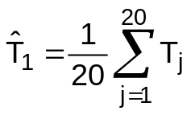,
where 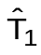 is an ensemble time series derived from N_{s} = 20 randomly selected stations and 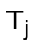 is a time series from the j^{th} station (1 ≤ N_{s} ≤ N-1).

- Compute thirty-year linear temperature or precipitation trends for each realization of an N_{s}-station ensemble time series.

- Repeat steps 1 through 3, with replacement of stations to sample, 100 times to generate multiple realizations of LSR network trends. For any N_{s}-station LSR network, MAE for temperature and precipitation trends is computed as:
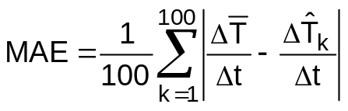.
where 100 is the number of Monte Carlo realizations, 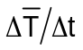 is the temperature or precipitation trend for the baseline time series, and 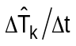 is the temperature or precipitation trend for k^{th} realization of an N_{s}-station LSR network.

- Repeat steps 1 through 4 for all possible LSR network sizes (N_{s} = 1, 2, …, N-1).

- Perform polynomial regression between MAE and LSR network size (N_{s}) by:
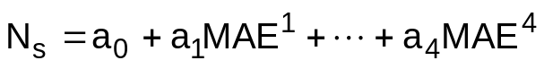.
A priori assumption is that MAE decreases as the LSR network density approaches the baseline network density. The selection criteria for resolving the United States climatic variability are based on the relationship between MAE and N_{s} (Fig. 3).

- Set monitoring goals (e.g., MAE = 0.1°C/decade) then solve polynomial model for N_{s}. Inside every grid cell, network densities required to meet the monitoring goals are determined. Typically, MAE decreases rapidly with increasing N_{s} for small numbers of stations (i.e., N_{s} from one to two or two to three), but the rate of change decreases markedly as N_{s} approaches N (Fig. 3).
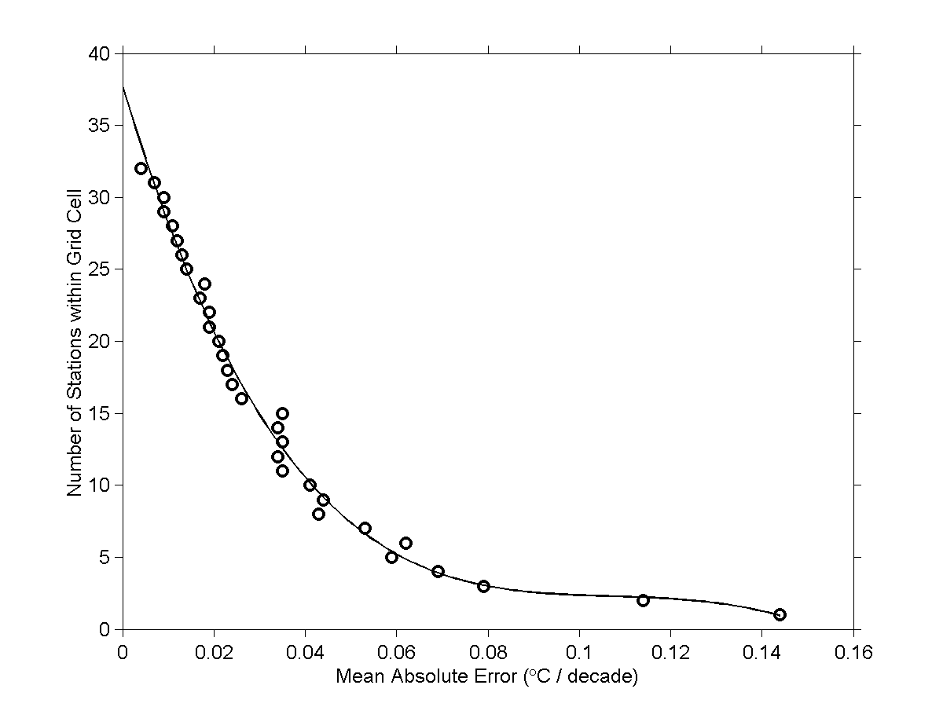
Figure 3 Sample relationship between MAE and the number of stations in the LSR network for a grid cell over north-central New Mexico. Circles are the median MAE for given N_{s} and the solid line is a polynomial model fit.

Resulting station densities

Gridded N_{s}-station networks corresponding to climate monitoring goals are mapped to provide valuable information regarding regions of the country that are most sensitive to network configuration and network density. Regions that are characterized by high spatial variability display a high degree of variability in temporal trends between Monte Carlo realizations and have overall higher mean-absolute errors.

Annual Air Temperature Trends

Four temperature-trend monitoring goals are examined and evaluated relative to a simple one-station-per-grid-cell network (Table 1). Temperature monitoring goals are consistent with observed global temperature trends (IPCC 2001, Karl et al. 1994). A monitoring goal for annual air temperature trends of 0.05°C/decade applied to the New Mexico grid cell, for example, would lead to a recommendation of eight stations for that location (Fig. 3). Solving a polynomial equation for N_{s} with this goal can be interpreted as identifying the network resolution necessary to reproduce annual air temperature trends from a baseline network to within 0.05°C/decade. A national network meeting a monitoring goal of 0.05°C/decade consists of 622 stations with an average of 5.5 stations per grid cell and an average station separation of 149 km. Regional patterns for network densities meeting this monitoring goal are not easily drawn (Fig. 4). The western United States (west of the 100th Meridian) requires 310 stations or an average of 6.2 stations per grid cell. The eastern United States requires 311 stations or 4.9 stations per grid cell. Approximately 55% of grid cells require 5 or more stations per cell to meet this monitoring goal (Fig. 5c). Three grid cells require ten or more stations. The three grid cells requiring only one or two stations are located along coastlines or where baseline density is limiting. Approximately 60% of grid cells require a 112-162 km spatial separation between stations to meet this monitoring goal (Fig. 5b).
Table 1 Integrated number of stations required to meet various temperature and precipitation monitoring goals.

Precipitation Trend (% median/decade) | Number of Stations | Temperature Trend (°C/decade) | Number of Stations
1.0 | 900 | 0.050 | 622
1.5 | 490 | 0.075 | 338
2.0 | 293 | 0.100 | 233
2.5 | 218 | 0.125 | 167
1 station per grid cell | 115 | 1 station per grid cell | 114

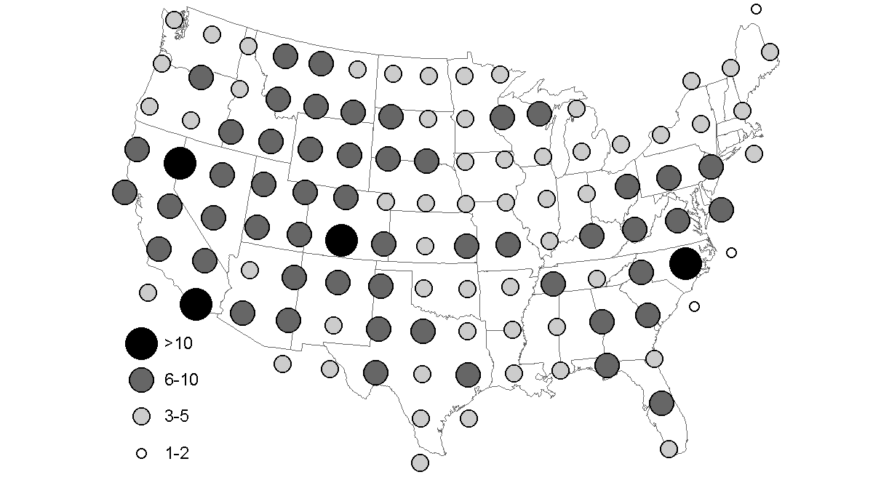
Figure 4 Grid-cell densities of 627 stations satisfying an annual temperature-trend monitoring goal of MAE < 0.05°C per decade. Graduated circles represent the number of stations within each grid cell.
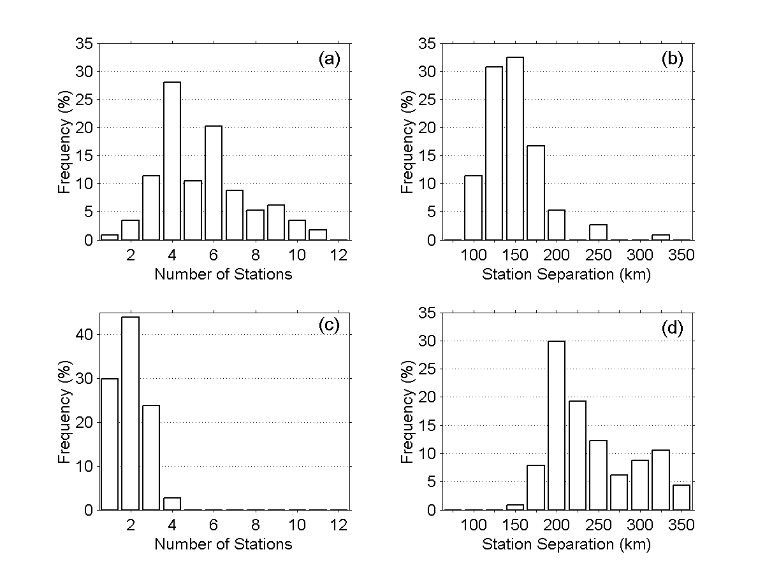
Figure 5 For LSR network meeting MAE ≤ 0.05°C per decade monitoring goal frequency distributions are for (a) number of stations per grid cell and (b) grid-cell station separation. For LSR network meeting MAE ≤ 0.10°C per decade monitoring goal frequency distributions are for (c) number of stations per grid cell and (d) grid-cell station separation.
A national network meeting a monitoring goal of 0.10°C/decade consists of 233 stations with an average station separation of 242 km. At least for temperature, station spacing increases and grid-cell density decreases as monitoring goals are relaxed. Thirty percent of grid cells require only one station to meet this monitoring goal (Fig. 5c). With nearly 100% of all cells requiring 3 or fewer stations to meet this monitoring goal, little spatial variability in network density results (Fig. 6). As a reflection of this, the western and eastern United States require an average of 2.1 and 2.0 stations per grid cell, respectively, to meet a 0.10°C/decade monitoring goal.

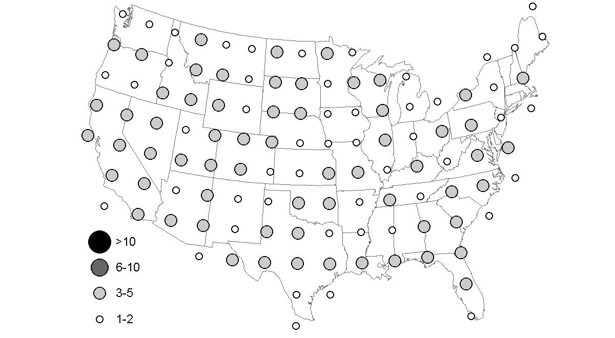
Figure 6 Grid-cell densities 233 stations satisfying an annual temperature-trend monitoring goal of MAE < 0.10°C per decade. Graduated circles represent the number of stations within each grid cell.

Two analyses are conducted to evaluate the performance of various LSR networks. Differences between average temperature trends measured by an N_{s}-station LSR network and those measured by the baseline network are examined. For each LSR network, there are no spatially systematic over or under estimates of baseline trends, nor are there regional patterns of larger or smaller differences (Fig. 7). Differences in trend estimates between an LSR network and a baseline network are largest with the simple one-station-per-grid-cell network (Fig. 7c). Increasing network density by increasing monitoring-goal precision decreases the differences between LSR network trend estimates and baseline trends (cf. Fig. 7a, 7b, 7c). Relative to one station per grid cell, LSR networks meeting more precise monitoring goals improve estimates of temperature trends.

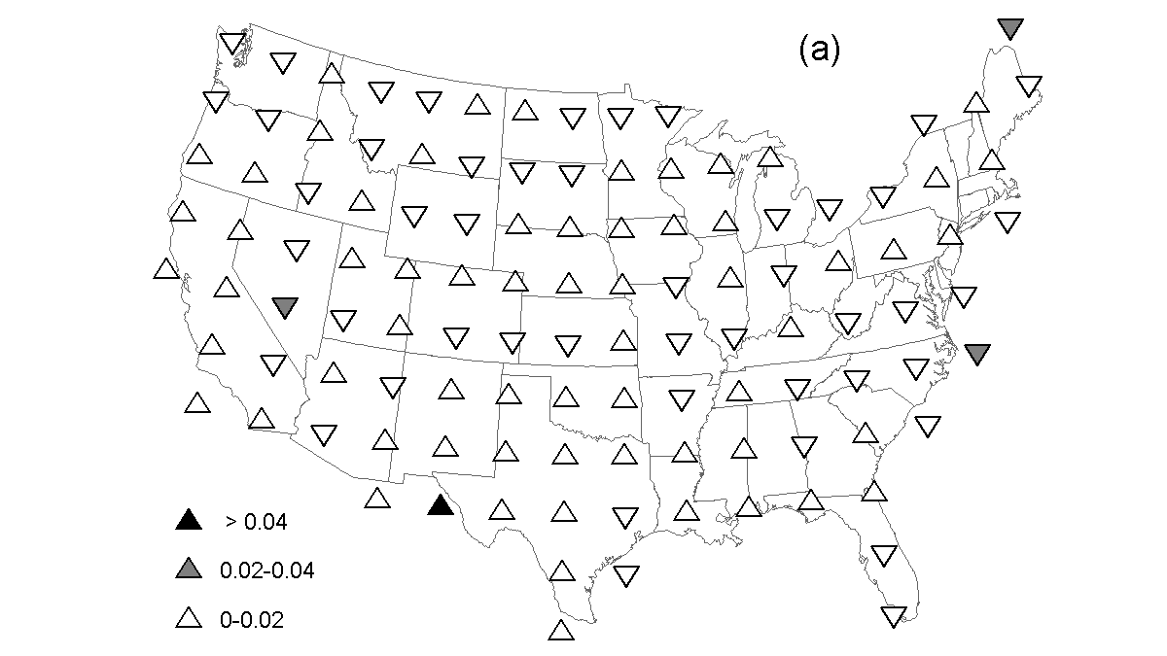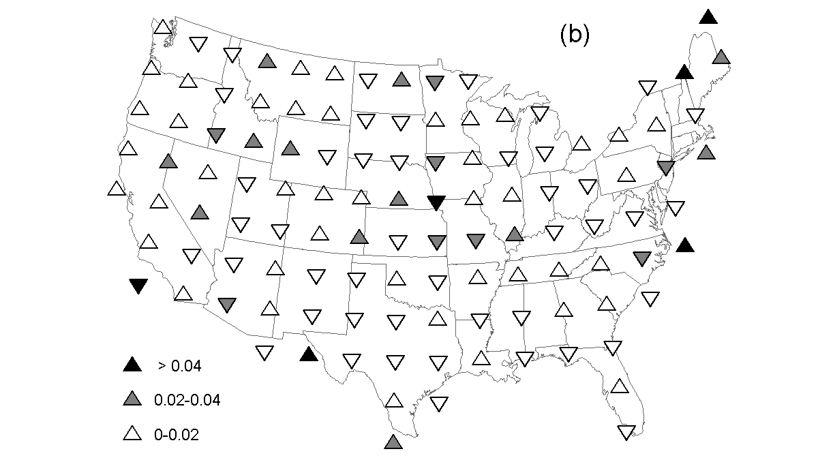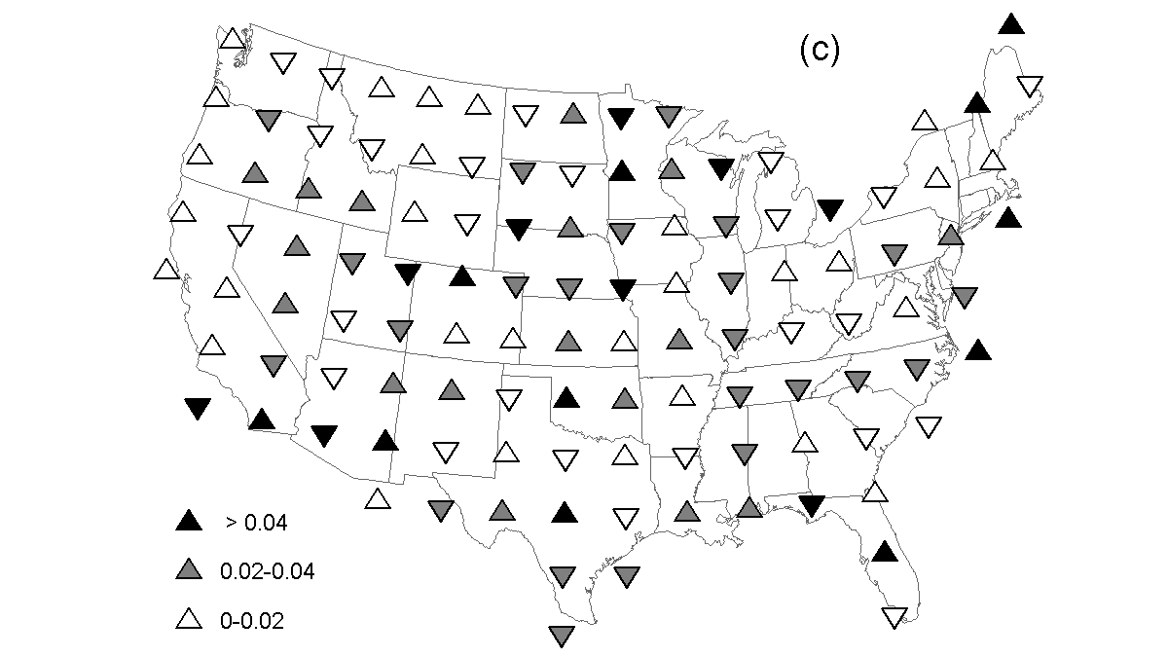
Figure 7 Within-grid differences between LSR network average trend estimates and baseline network trends for (a) 0.05ºC per decade and (b) 0.10ºC per decade monitoring goals and (c) one station per grid cell. Upward triangles indicate where the LSR network trend estimates are greater than the baseline network trends. Downward triangles indicate where the LSR network trend estimates are less than the baseline network trends.
As monitoring goals become more exact, the range of estimated grid-cell trends decreases. For each grid cell, there are 100 Monte Carlo simulations for each LSR network size producing 100 different trend estimates for each LSR network size. These multiple realizations allow one to exploit univariate measures such as standard deviation and the range of trend estimates to evaluate the performance of LSR network recommendations. For the New Mexico example, more precise monitoring goals increases the number of stations that in turn decreases the range and standard deviation of trend estimates (Fig. 8). In this example, an 8-station network produces trends within the range 0.138°C/decade and 0.391°C/decade with a standard deviation of 0.005°C/decade. A 16-station network produces trends within the range 0.182°C/decade and 0.335°C/decade with a standard deviation of 0.003°C/decade. With predetermined monitoring goals, the numbers of stations within each grid cell are identified. For these station densities, these performance measures show the degree of variability (or error) in trend estimates that may exist within the grid cells of an LSR network.

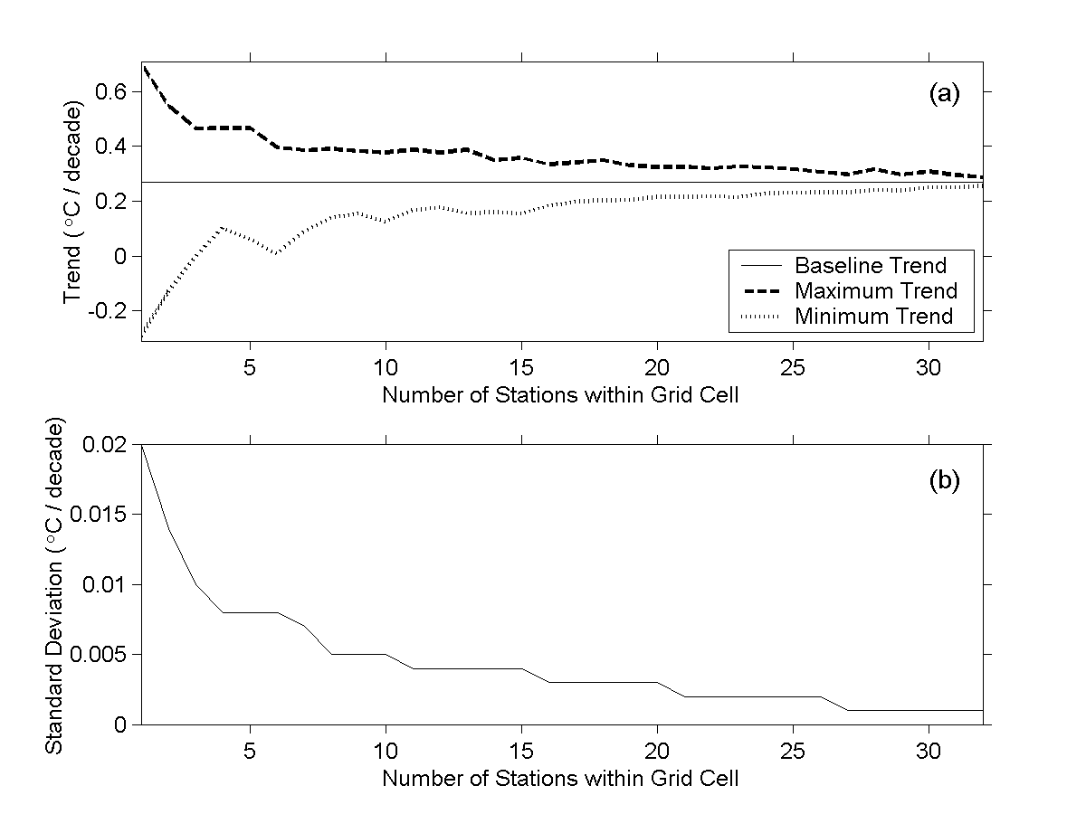
Figure 8 Sample relationship between the number of stations per grid cell versus (a) the range of Monte Carlo simulated temperature trends and (b) the standard deviation of Monte Carlo simulated temperature trends. Maximum (or minimum) indicates the largest positive (or negative) trend that is estimated by any LSR network of size identified on the abscissa.

For the 0.05°C/decade monitoring goal, LSR network trend estimates across 90% of grid cells are within approximately ±0.15°C/decade of their respective baseline trends and within ±0.20°C/decade across 100% of the grid cells (Fig. 9a). The range of trend estimates for all LSR network sizes represents the maximum difference between Monte Carlo trend estimates and baseline trends and should not be confused with the average differences that, by definition, are less than the monitoring goals. In Fig. 8, for example, the minimum and maximum Monte Carlo trend estimates approach the baseline trends but typically do not intersect. Comparatively, for the 0.10°C/decade monitoring goal LSR network trend estimates across only 10% of all grid cells are within ±0.15°C/decade of their respective baseline trends. Networks created based on the less precise monitoring goal of 0.10°C/decade may have less precise trends over some areas (Fig. 9). Regardless of monitoring goals and resulting grid-cell station density, few grid cells experience very small ranges between Monte Carlo grid-cell trend estimates (i.e., less than 0.2°C/decade). Tails on the upper end of the frequency distribution indicate the percentage of grid cells that experience large trend differences or standard deviations in Monte Carlo trend estimates. The standard deviations and ranges of Monte Carlo trend estimates illustrate that applying more precise monitoring goals improves the LSR network performance, especially relative to a simple one-station-per-grid network (Fig. 9). Selection of LSR network size should be based on relative improvements and acceptable thresholds of climatic variability.

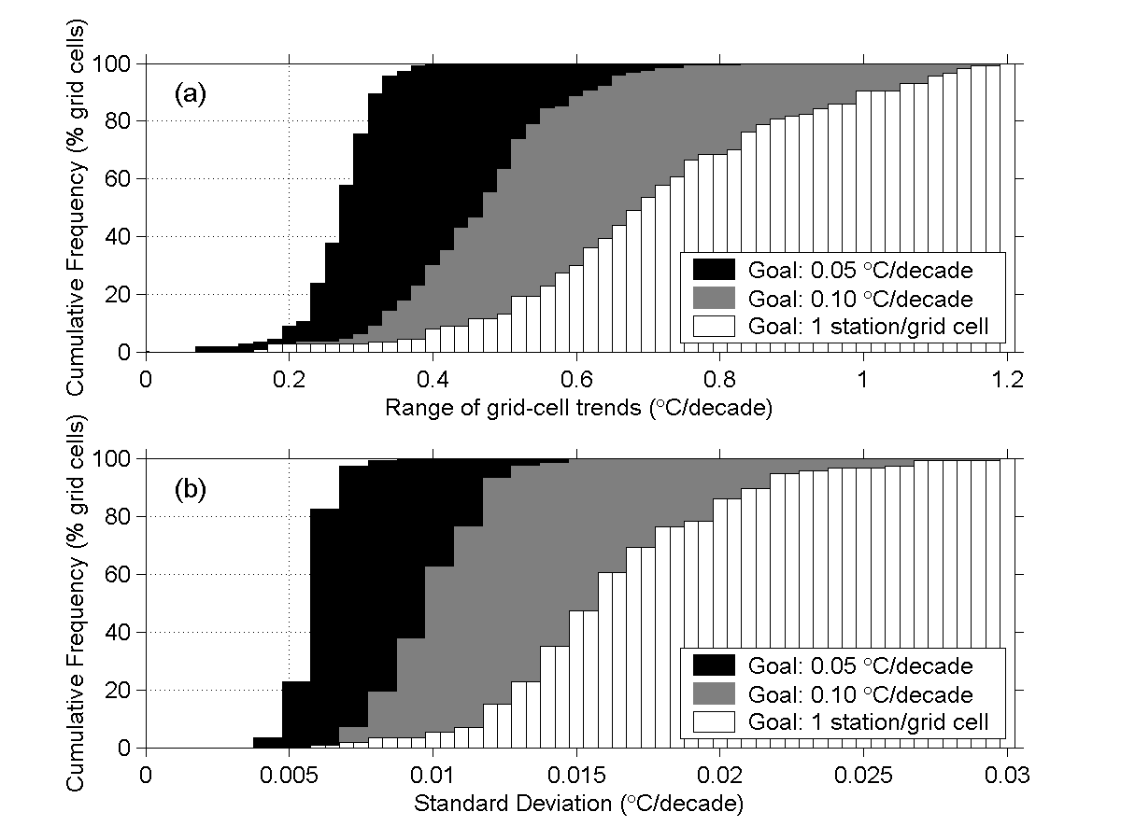
Figure 9 Cumulative percentages of grid cells within range of temperature trends estimated by Monte Carlo procedure. Three cumulative frequencies represent range of temperature trends resulting from two monitoring goals and a null hypothesis of one station per grid cell.

Annual Precipitation Trends

Four precipitation-trend monitoring goals are examined and compared to a simple one-station-per-grid-cell network (Table 1). Precipitation trend monitoring goals are based on observed annual trends less than ±5% per decade across the contiguous United States (Karl and Knight 1998). A national network meeting a monitoring goal of 1.5% of median annual precipitation per decade consists of 490 stations with an average of 4.3 stations per grid cell and an average station separation of 173 km (based on 1971-2000 reference period). The most frequent (>20%) number of stations per cell meeting this monitoring goal is 3 (Fig. 10a). Approximately 45% of grid cells require a 137-187 km spatial separation between stations to meet this monitoring goal (Fig. 10b). Higher station densities are generally required west of the 100th Meridian, with the highest station densities occurring in the southwestern United States (Fig. 11). The western United States requires 275 stations or an average of 5.4 stations per grid cell while the eastern United States requires 215 stations or an average of 3.4 stations per grid cell.

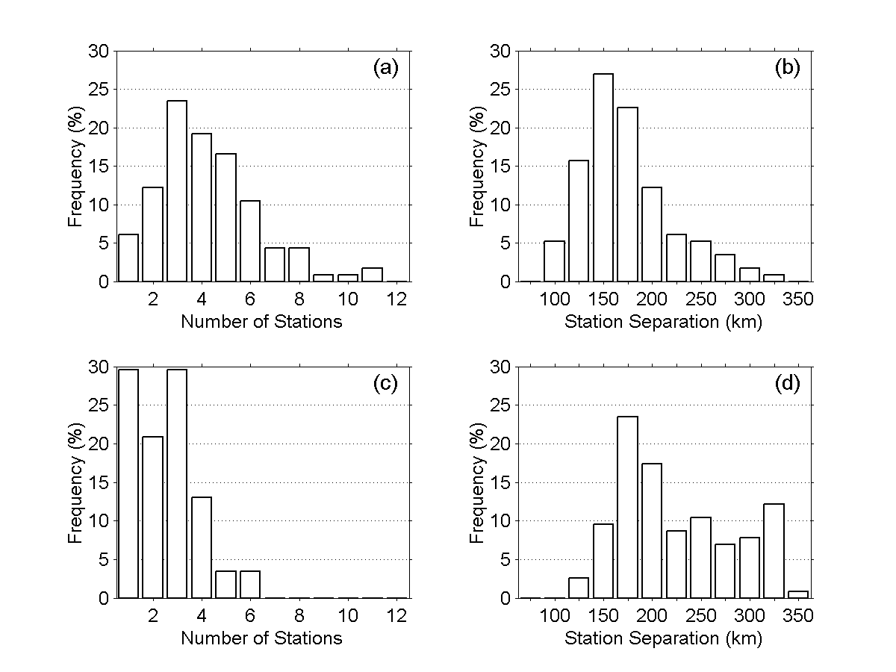
Figure 10 For LSR network meeting MAE ≤ 1.5% median precipitation per decade monitoring goal, frequency distributions are for (a) number of stations per grid cell and (b) grid-cell station separation. For LSR network meeting MAE ≤ 2.0% median precipitation per decade monitoring goal, frequency distribution are for (c) number of stations per grid cell and (d) grid-cell station separation.

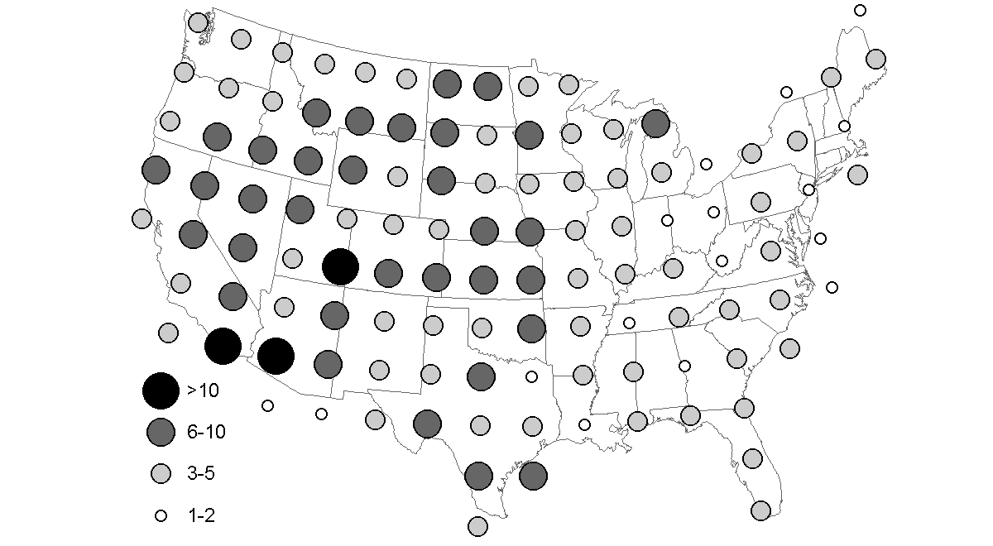
Figure 11 Grid-cell densities of 490-station LSR network satisfying an annual precipitation-trend monitoring goal of MAE < 1.5% median precipitation per decade. Graduated circles represent the number of stations within each grid cell.

A national network meeting a monitoring goal of 2.0% of median annual precipitation per decade consists of 293 stations with an average of 2.5 stations per grid cell and an average station separation of 225 km (Table 1). Thirty percent of grid cells require only one station to meet this monitoring goal (Fig. 10c). The most common spatial separation per grid cell is 162-212 km, but higher resolutions (e.g., >300 km) are necessary for some grid cells (Fig. 10d). To meet this monitoring goal, higher network densities are necessary in the western United States (west of the 100th Meridian), while lower network densities are necessary in the eastern United States (Fig. 12). The western United States requires 168 stations or an average of 3.3 stations per grid cell. The eastern United States requires 125 stations or an average of 1.9 stations per grid. For precipitation trends, station separation is greater and station density is less when monitoring goals are relaxed.

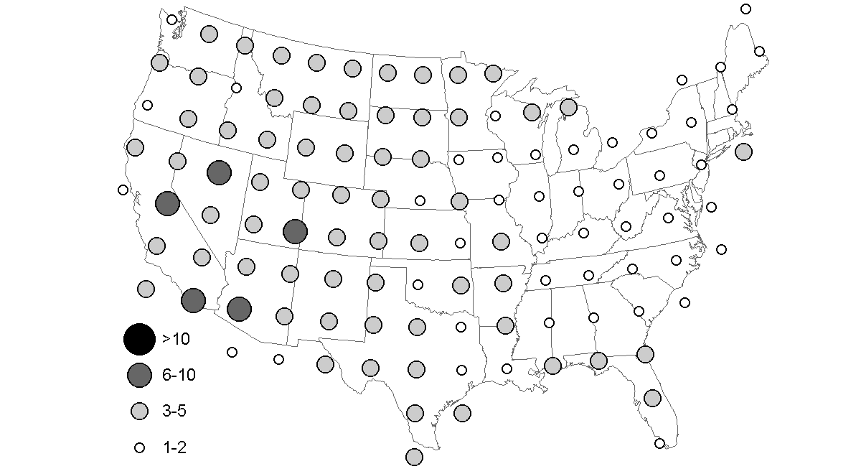
Figure 12 Grid-cell densities of 293-station LSR network satisfying an annual precipitation-trend monitoring goal of MAE < 2.0% median precipitation per decade. Graduated circles represent the number of stations within each grid cell.

Again, difference between average trends measured by a typical N_{s}-station LSR network and those measured by the baseline network are examined (Fig. 13). Differences in trend estimates between an LSR network and the baseline network generally increase as monitoring goals become less precise and reach a maximum with the one-station-per-grid-cell network. As with temperature trends, there are no apparent spatial patterns to network performance. Although the relative improvement in network performance when monitoring goals are applied is universal, the maps indicate the location of potential improvements to climate monitoring based on increased network density.
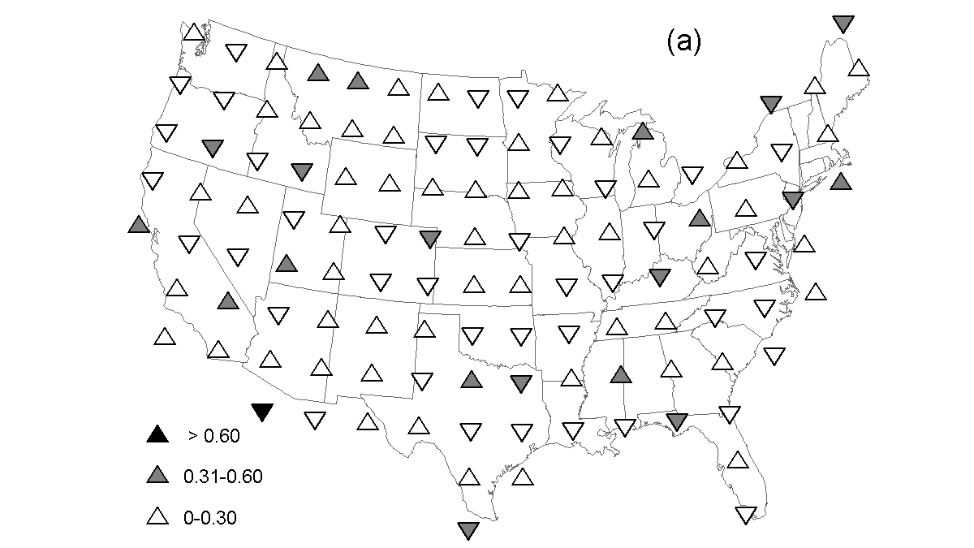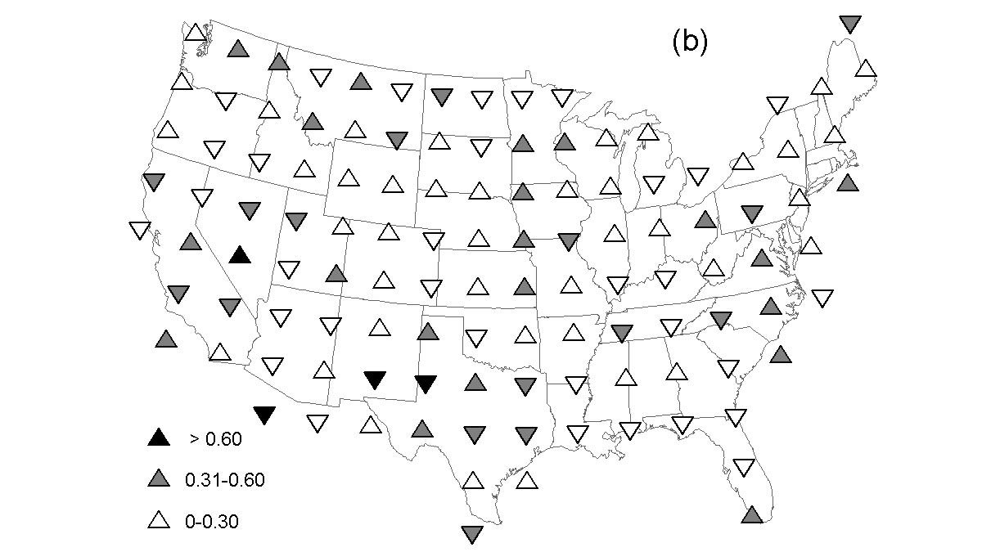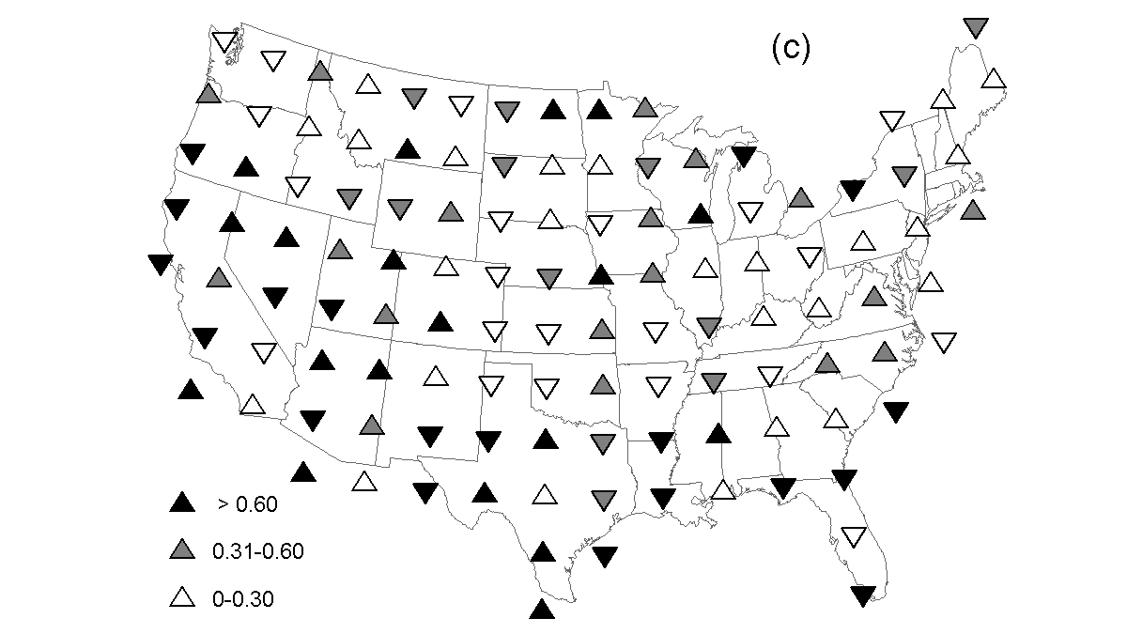
Figure 13 Same as Fig. 6 but for the precipitation monitoring goals of (a) 1.5% median precipitation per decade and (b) 2.0% median precipitation per decade and (c) one station per grid cell.

The ranges and standard deviation of precipitation trends within each grid cell for 100 Monte Carlo realizations are estimated and examined as cumulative frequencies across the network (Fig. 14). More precise monitoring goals decrease the range and variability of trend estimates. When compared to a simple on-station-per-grid-cell network, both LSR networks can substantially decrease the variability of trend estimates (cf. Fig. 10 and Fig. 12). Milewske and Hogg (2001) found a maximum interstation distance of 1339 km for interpolating annual precipitation in southern Canada. Maximum interstation distances for monthly precipitation were between 563 and 699 km. Their error criterion of 10% of annual precipitation is substantially greater than the monitoring goals applied here. Moreover, examination of network performance with error criteria based on percent precipitation trends should lead to spatially different recommendations for network density.

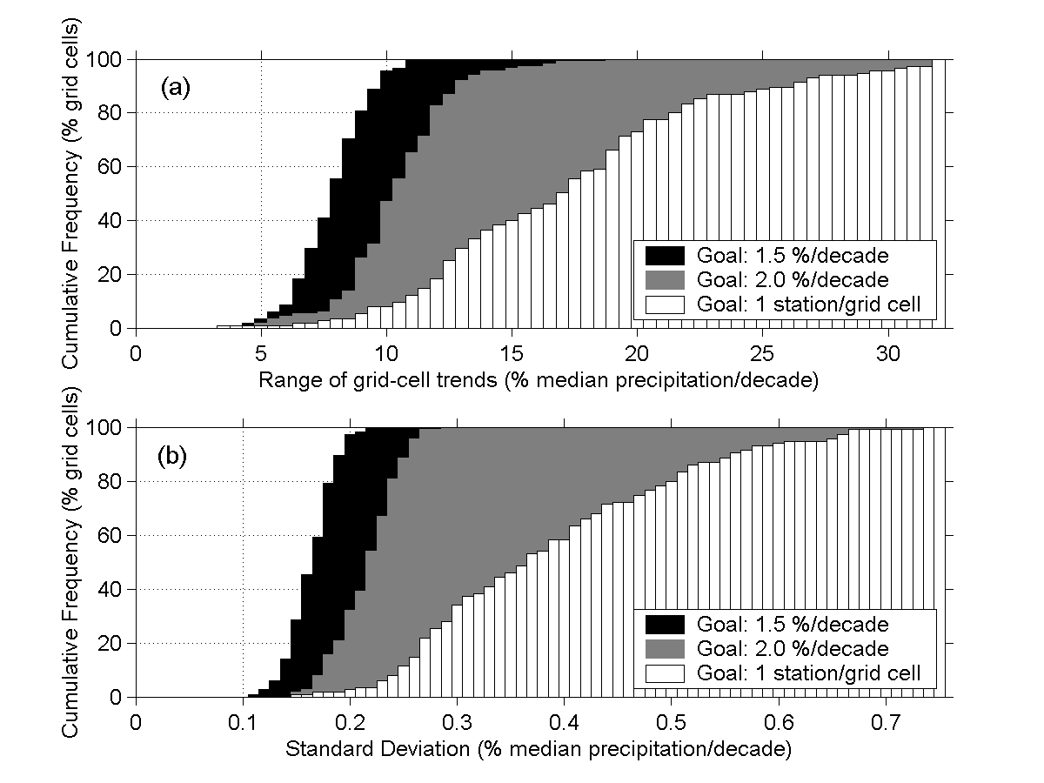
Figure 14 Cumulative percentages of grid cells within range of precipitation trends estimated by Monte Carlo procedure. Three cumulative frequencies represent range of precipitation trends resulting from two monitoring goals and a null hypothesis of one station per grid cell.

Summary and Discussion

A goal of this work is to provide a recommendation for CRN station density. Spatial density is examined relative to measured precipitation and temperature from a spatially dense network of existing weather stations. The assumed minimum station density is a uniform spatial distribution of one station per 2.5° latitude × 3.5° longitude grid. The effect of this resolution has not been systematically evaluated but it is consistent with GCM resolutions and gridded climatic fields (IPCC 2001). The grid-based approach provides regional estimates of network density that satisfy predetermined monitoring goals. A stratified local sampling strategy with Monte Carlo resampling techniques applied within each grid cell are used to build information on how trend estimates may diverge with decreasing network density. Regions of the country that require higher station densities to meet climate-monitoring goals are identified. Although these techniques make an initial assumption regarding uniformity, the resulting LSR networks display no dependencies with respect to baseline network densities (Fig. 15).

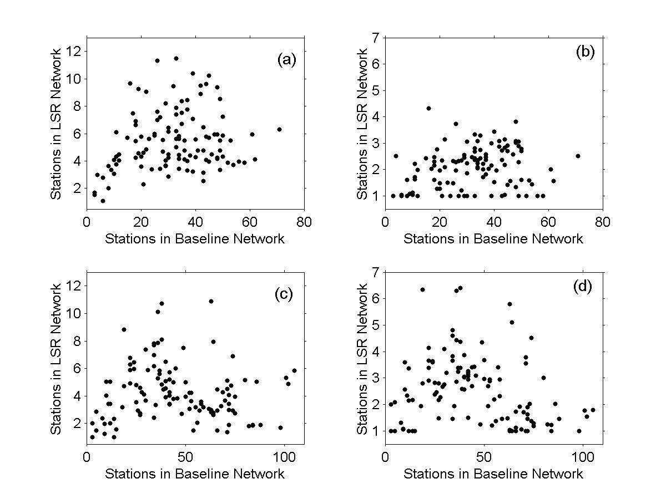
Figure 15 Number of stations in LSR network for each grid cell relative to the number of stations in baseline networks. Panes represent LSR networks meeting climate monitoring goals for (a) 0.05°C per decade annual temperature trend (r = 0.21), (b) 0.10°C per decade annual temperature trend (r = 0.14), (c) 1.5% median precipitation per decade annual precipitation trend (r = − 0.04), and (d) 2.0% median precipitation per decade annual precipitation trend (r = − 0.22).

Network densities resulting from 0.10 °C per decade and 2.0% of median annual precipitation per decade monitoring goals are superimposed. The larger number of stations within each grid cell for either monitoring goal determines the combined network density. The result provides a minimum density estimate for national climatic change networks (Fig. 16). A national network meeting the combined monitoring goals consists of 327 stations with an average of 2.9 stations per grid cell. The western United States (west of the 100th Meridian) requires 168 stations or an average of 3.4 stations per grid cell while the eastern United States requires 159 stations or 2.5 stations per grid cell. Comparing the combined network density map (Fig. 16) to the maps for individual monitoring goals (Figs. 6 and 12) shows that higher densities in the west are driven by precipitation monitoring while temperature monitoring drives higher densities in the east.

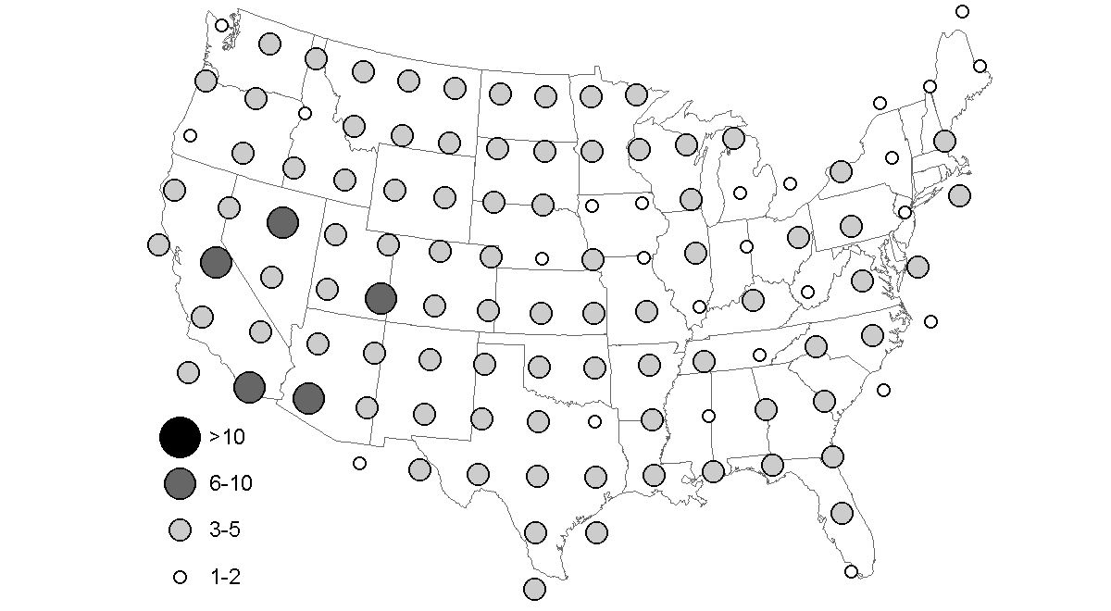
Figure 16 Grid-cell densities of combined 327 stations satisfying an annual temperature-trend monitoring goal of MAE < 0.10°C per decade and a precipitation-trend monitoring goal of 2% median annual precipitation per decade. Graduated circles represent the number of stations within each grid cell.

References

DeGaetano, A. T., 2001: Spatial grouping of United States climate stations using a hybrid clustering approach. Int. J. Climatol., 21, 791–807.
Easterling, D. R., T. R. Karl, E. H. Mason, P. Y. Hughes, and D. P. Bowman, 1996: United States Historical Climatology Network (U.S. HCN) Monthly Temperature and Precipitation Data. ORNL/CDIAC-87 NDP-019/R3. Carbon Dioxide Information Analysis Center, Oak Ridge National Laboratory. [Available from National Technical Information Service, 5285 Port Royal Rd., Springfield, VA 22161.]
Easterling, D. R., and Coauthors, 1997: Maximum and minimum temperature trends for the globe. Science, 277, 364–367.
Gordon, C., and Coauthors, 2000: The simulation of SST, sea ice extents and ocean heat transports in a version of the Hadley Centre coupled model without flux adjustments. Climate Dyn., 16, 147–168.
Hubbard, K. G., 1994: Spatial variability of daily weather variables in the high plains of the USA. Agric. Forest Met., 68, 29–41.
Intergovernmental Panel on Climate Change (IPCC), 2001: Climate Change 2001: The Scientific Basis. Houghton, J. T., and Coauthors, eds. Cambridge University Press, Cambridge, UK, 944 pp.
Karl, T. R., and R. W. Knight, 1998: Secular trends of precipitation amount, frequency, and intensity in the United States. Bull. Amer. Meteor. Soc., 79, 231–241.
Karl, T. R., R. W. Knight, and J. R. Christy, 1994: Global and hemispheric temperature trends: Uncertainties related to inadequate spatial sampling. J. Climate, 7, 1144–1163
Milewska, E., and W. D. Hogg, 2001: Spatial representativeness of a long-term climate network in Canada. Atmos.-Ocean, 39, 145–161.
New, M., M. Hulme, and P. Jones, 2000: Representing twentieth-century space–time climate variability. Part II: development of 1901–96 monthly grids of terrestrial surface climate. J. Climate, 13, 2217–2238.
NCDC, 2002: Climatography of the U.S. No. 81: Monthly Station Normals of temperature, Precipitation, and Heating and Cooling Degree Days 1971-2000. National Climatic Data Center, CD-ROM. [Available online at http://nndc.noaa.gov/onlinestore.html.]
Robeson, S. M., and M. J. Janis, 1998: Comparison of temporal and unresolved spatial variability in multiyear time-averages of air temperature. Climate Res., 10, 15–26.
von Storch, H., and F. W. Zwiers, 1999: Statistical Analysis in Climate Research. Cambridge University Press, Cambridge, UK, 484 pp.
Willmott, C. J., S. M. Robeson, and M. J. Janis, 1996: Comparison of approaches for estimating time-averaged precipitation using data from the USA. Int. J. Climatol., 16, 1103–1115.

